ANCILLARY STRUCTURES PRE-INSTALLATION  VERIFICATION TEST OF HIGH STRENGTH BOLTS    DT2322 2/2015 | Wisconsin Department of Transportation
This form should be filed with the completed project file as a permanent record. This form should not be used for highway bridges.
PRE-INSTALLATION
Purpose of Test: Establish individual installation requirements for structural fasteners and DTI’s by performing and verifying
that tension obtained in three samples of each fastener assembly lot is at least 5% above the minimum installation tension.
Perform prior to installing fasteners in ancillary structures and record the results along with the fastener assembly lot information.
INSTRUCTIONS
- Fill in the information regarding each lot combination, noting that each combination to be used requires a separate test.
- Take 3 fastener assemblies (A325 Bolt, A563 Nut, F436 Washer*) from a lot previously tested with a rotational capacity test
and ASTM F959 DTI’s. Test in the same configuration as the bolts and DTI’s are being installed in the structure (note step 8).
- Lubricate nut (face and threads) with wax based lubricant.
- Tension with a calibrated torque wrench until reaching the minimum number of refusals from Table 1, measured with a .005" feeler gauge. If 100% refusals are obtained prior to reaching the tension in Table 2, the lot of DTI’s fails.
- Record the measured torque and tension in Table 3.
- Verify the torque is below the maximum in Table 4 (see page 2) and the tension meets the minimum in Table 2.
- Repeat steps 3 through 6 and record the information in Table 3 below.
- Check the configuration used during testing:
DTI Under Head, Turn Nut (preferred)  DTI Under Head, Turn Head | DTI Under Nut, Turn Nut  DTI Under Nut, Turn Head
*Note: Special washers may be required for larger bolts.

 | Bolt | Nut | Washer | DTI
Manufacturer
Lot Number
Diameter/Length |  | Note: Each fastener assembly lot requires a separate worksheet.

Table 1. DTI Refusals
Number of Gaps | 4 | 5 or 6 | 7 or 8
Minimum Number of Refusals | 2 | 3 | 4

Table 2. Minimum Installation Tension Required for the Pre-installation Test
Bolt Dia. | 3/4" | 7/8" | 1" | 1 1/8" | 1 1/4" | 1 3/8" | 1 1/2"
A325 Kips | 29 Kips | 41 Kips | 54 Kips | 59 Kips | 75 Kips | 89 Kips | 108 Kips

Table 3.
Sample | Measured Tension | Tension Acquired? | Measured Torque | Torque  Below MAX? | Number of Refusals | Refusals Acceptable?
1
2
3
 |  |  |  | Average Total:

Bolt-Tension Measuring Device – Make, Model and Serial Number |  |  | Calibration Date (m/d/yyyy)
Torque Wrench – Make, Model and Serial Number (prior to Calibration Date)

Torque Wrench Calibration Date (m/d/yyyy) (Calibration Date MUST be Within 1 Year) |  | Project ID Number
Contractor Name

Date (m/d/yyyy) | Contractors Representative (QC) Name | Contractors Representative (QC) Signature  X
Date (m/d/yyyy) | Wisconsin Department of Transportation Representative (QA) Name | WisDOT Representative (QA) Signature  X
Complete to this point once for all structures within the same contract and for the same combination of fastener assembly and DTI.
(Copy to furnish individually for each structure).
ANCILLARY STRUCTURES PRE-INSTALLATION VERIFICATION TEST OF HIGH STRENGTH BOLTS (continued)
Wisconsin Department of Transportation DT2322

Table 4. Maximum Allowable Torque (Tension is measured in Kips or 1,000s of pounds and torque is measured in ft.-lbs.)
3/4" Diameter |  | 7/8" Diameter |  | 1" Diameter |  | 1 1/8" Diameter |  | 1 1/4" Diameter |  | 1 3/8" Diameter |  | 1 1/2" Diameter
Kips Tension | Max. Torque | Kips Tension | Max. Torque | Kips Tension | Max. Torque | Kips Tension | Max. Torque | Kips Tension | Max. Torque | Kips Tension | Max. Torque | Kips Tension | Max. Torque
29 | 453 | 41 | 748 | 54 | 1121 | 59 | 1387 | 75 | 1950 | 89 | 2559 | 108 | 3375
30 | 469 | 42 | 767 | 55 | 1141 | 60 | 1410 | 76 | 1976 | 90 | 2588 | 109 | 3406
31 | 484 | 43 | 785 | 56 | 1162 | 61 | 1434 | 77 | 2002 | 91 | 2616 | 110 | 3438
32 | 500 | 44 | 803 | 57 | 1183 | 62 | 1457 | 78 | 2028 | 92 | 2645 | 111 | 3469
33 | 516 | 45 | 821 | 58 | 1204 | 63 | 1481 | 79 | 2054 | 93 | 2674 | 112 | 3500
34 | 531 | 46 | 840 | 59 | 1224 | 64 | 1504 | 80 | 2080 | 94 | 2703 | 113 | 3531
35 | 547 | 47 | 858 | 60 | 1245 | 65 | 1528 | 81 | 2106 | 95 | 2731 | 114 | 3563
36 | 563 | 48 | 876 | 61 | 1266 | 66 | 1551 | 82 | 2132 | 96 | 2760 | 115 | 3594
37 | 578 | 49 | 894 | 62 | 1287 | 67 | 1575 | 83 | 2158 | 97 | 2789 | 116 | 3625
38 | 594 | 50 | 913 | 63 | 1307 | 68 | 1598 | 84 | 2184 | 98 | 2818 | 117 | 3656
39 | 609 | 51 | 931 | 64 | 1328 | 69 | 1622 | 85 | 2210 | 99 | 2846 | 118 | 3688
40 | 625 | 52 | 949 | 65 | 1349 | 70 | 1645 | 86 | 2236 | 100 | 2875 | 119 | 3719
41 | 641 | 53 | 967 | 66 | 1370 | 71 | 1669 | 87 | 2262 | 101 | 2904 | 120 | 3750
42 | 656 | 54 | 986 | 67 | 1390 | 72 | 1692 | 88 | 2288 | 102 | 2933 | 121 | 3781
43 | 672 | 55 | 1004 | 68 | 1411 | 73 | 1716 | 89 | 2314 | 103 | 2961 | 122 | 3813
44 | 688 | 56 | 1022 | 69 | 1432 | 74 | 1739 | 90 | 2340 | 104 | 2990 | 123 | 3844
Use PD/4 for other value not on this form. Where P=Tension in Kips, D=diameter of bolts in feet (divide by 12 to obtain feet).
Each fastener assembly lot consists of one bolt, nut, washer(s) and a DTI which comes with its individual lot.
If any component is from a different lot a separate test shall be performed.
Note: The preinstallation test need only be performed per lot – per contract. A copy of this test should be kept with the lot
until the entire lot is used up.

INSTALLATION
Once the pre-installation test has been preformed the following steps should be performed for installation:  - Lubricate each nut (face and threads) with wax based lubricant just prior to installation.  - Install bolts with the same configuration as tested in the Preinstallation Test Step 8. Install with the number of hardened washers as specified in the shop drawings.  - Snug connection from tightest point to edge until the plies are in firm contact at each bolt.  - Once all the bolts are snugged – tension the bolts until each DTI reaches one refusal more than the average of three in Table 3. | 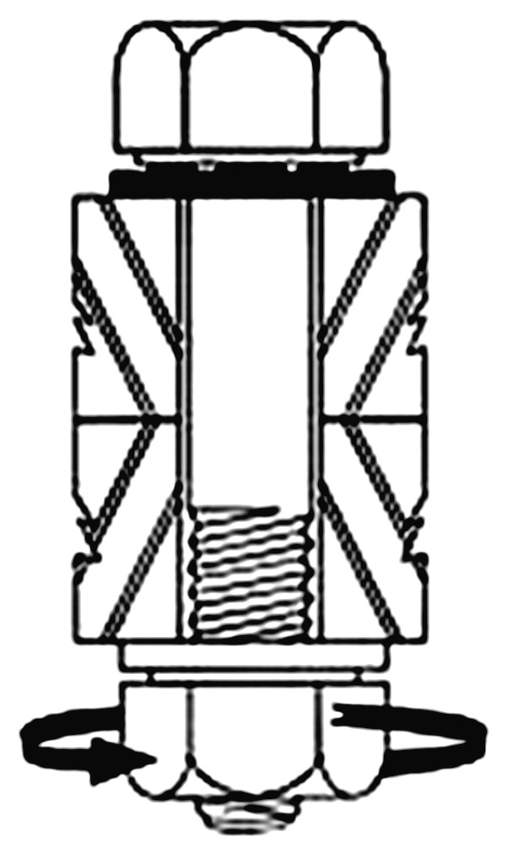  DTI under head, turn nut to tighten, bolt head held.  Preferred method, shown for informational purposes only.
QUALITY CONTROL
The contractors QC should check the following items for each connection of each structure.
Check that bolts, nuts, and washers are the correct grade and type, along with documentation of the Ro-Cap test performed by the supplier – See Step 2 (page 1).
Check that washers for bolts over 1 1/8" conform to DTI manufacturer's recommendations and shall only be 1/16" diameter larger ID than the bolt diameter.
Check that hardened washers are used on plies that have oversized bolt holes (when necessary) and match the number of hardened washers specified in the shop drawings.
Check the configuration of the bolt assembles is the same as the preinstallation – Test Step 8.
Check the plies to be in firm contact at each bolt prior to tensioning.
Check that DTI’s are compressed to one more refusal than the average found in Table 3.
Check any shop installed A325 bolts that have been tensioned or reinstalled in the field.
Torque Wrench – Make, Model and Serial Number (prior to Calibration Date)

Torque Wrench Calibration Date (m/d/yyyy) (Calibration Date MUST be Within 1 Year) |  | Structure ID Number
Contractor Name

Date (m/d/yyyy) | Contractors Representative (QC) Name | Contractors Representative (QC) Signature  X
Date (m/d/yyyy) | Wisconsin Department of Transportation Representative (QA) Name | WisDOT Representative (QA) Signature  X

