MEDICAL EXAMINATION REPORT
Wisconsin Department of Transportation
SP4419 9/2014

The Wisconsin Law Enforcement Standards Board, under LES 2.01(f)(1)(2), requires that a peace officer candidate be examined by a licensed physician or surgeon to ensure that the applicant is free of any physical defect or medical condition which might adversely affect job performance.
This form is designed to be used in conjunction with the Medical History Statement (Form SP4414) to evaluate an applicant's qualifications for the position of Wisconsin State Patrol Trooper/Inspector. Both forms concentrate only on those areas which have been determined to be medically related to the requirements of a Wisconsin State Patrol officer. Please review the Medical History Statement before examining the candidate.
Legal Name: Last | First | Middle |  | Birth Date (m/d/yyyy) | Sex  Male Female
Height (without shoes)  (Ft/Inches) |  |  | Weight (without shoes or coat)  (Lb/Kg)
VITAL SIGNS
Blood Pressure (sitting)  Right or Left Arm | Pulse  Rate Rhythm | Resp. | Temperature

NORMAL / ABNORMAL | CHECKLIST | DETAILED DESCRIPTION OF ABNORMAL FINDINGS
Hands/Skin  Normal / Abnormal  Normal / Abnormal  Normal / Abnormal | Hands/Skin  Hair  Skin/Color/Texture  (Lesions, Scars)  Nails
Head/Eyes  Normal / Abnormal  Normal / Abnormal  Normal / Abnormal  Normal / Abnormal  Normal / Abnormal  Normal / Abnormal  Normal / Abnormal | Head/Eyes  Configuration  Lids  Conj/Sclers  Pupils/Equal  Light Reaction  Fundi (Undilated Eyes)  EOM
Ears/Nose/Throat/Mouth  Normal / Abnormal  Normal / Abnormal  Normal / Abnormal  Normal / Abnormal  Normal / Abnormal | Ears/Nose/Throat/Mouth  Pinna/Canals/TM  Nasal Septum/Mucosa  Teeth/Gums  Tongue/Palate  Tonsils/Pharynx
Neck/Nodes  Normal / Abnormal  Normal / Abnormal  Normal / Abnormal  Normal / Abnormal  Normal / Abnormal  Normal / Abnormal | Neck/Nodes  Bruit  ROM  Muscle Strength  Thyroid  Neck Nodes  Inguinal/Auxillary Nodes

MEDICAL EXAMINATION REPORT (continued) Wisconsin Department of Transportation
SP4419

NORMAL / ABNORMAL | CHECKLIST | DETAILED DESCRIPTION OF ABNORMAL FINDINGS
Chest/Lungs  Normal / Abnormal  Normal / Abnormal  Normal / Abnormal  Normal / Abnormal | Chest/Lungs  Shape/Symmetry/ Diaphragmatic  Excursion  Auscultation  Breasts (Discharge/Masses)
Cardiovascular  Normal / Abnormal  Normal / Abnormal  Normal / Abnormal  Normal / Abnormal  Normal / Abnormal | Cardiovascular  Carotids  Neck Veins  Pulses: Radial  D. Pedis  Heart Sounds (Murmurs)
Abdomen  Normal / Abnormal  Normal / Abnormal  Normal / Abnormal  Normal / Abnormal  Normal / Abnormal | Abdomen  Hernia  Shape  Bowel Sounds (Bruits)  Liver/Spleen  Masses
Musculoskeletal/Extremities  Normal / Abnormal  Normal / Abnormal  Normal / Abnormal  Normal / Abnormal | Musculoskeletal/Extremities  Spine  Extremities (Edema/Varicosities)  Joints  ROM
Nervous System  Normal / Abnormal  Normal / Abnormal  Normal / Abnormal  Normal / Abnormal  Normal / Abnormal | Nervous System  CN  Motor  Sensory  Cerebellar  Reflexes
Genitalia/Rectal  Normal / Abnormal  Normal / Abnormal  Normal / Abnormal  Normal / Abnormal  Normal / Abnormal  Normal / Abnormal | Genitalia/Rectal  Male: Penis  Scrotum/Testes  Hernia  Prostate  Female: Perineum/Vagina  Cervix/Uterus/Adnexa
LABORATORY FINDINGS
Urine Dip
Protein | Specific Gravity | Glucose

MEDICAL EXAMINATION REPORT (continued) Wisconsin Department of Transportation
SP4419

VISION
Visual Acuity (If applicant wears glasses, test and record acuity both with and without glasses.)
Without Correction | R20/ | L20/ | B20/
With Correction | R20/ | L20/ | B20/
Depth Perception |  | Color Perception | Tonometry
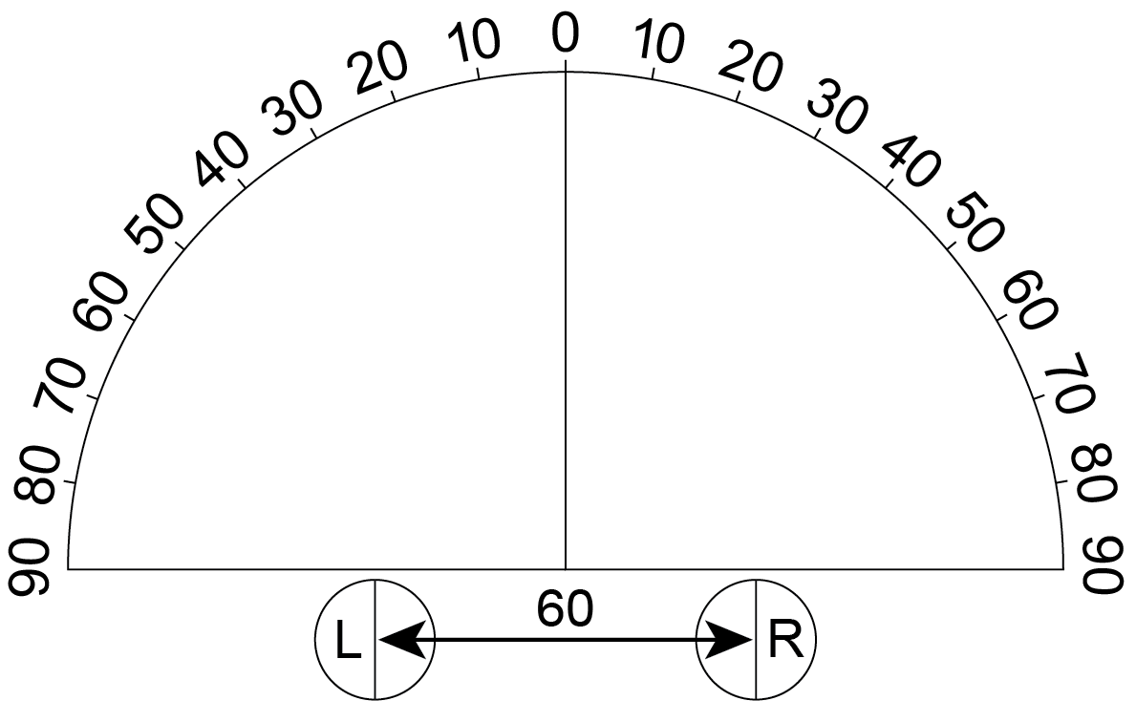
FORM FIELDS OF VISION (Temporal)
Record degrees of temporal fields obtained by confrontations in space and on diagram
Right Eye  (Eye on Zero Line) | Left Eye  (Eye on Zero Line)

MEDICAL FINDINGS/OPINION
No Yes Based on your examination, information supplied on the medical history statement, and any other information obtained and considered, it there any physical or medical condition which in your opinion, would substantially impair this person's ability to fully perform as a State Patrol Trooper/Inspector?
(If yes complete the following. Attach additional sheets if needed.)

Medical Condition or Disease

Any Qualifying Statements - Related or Additional Circumstances

Rationale for decision, including job behavior affected

 | X
 | (Examining Physician Signature) | (Date – m/d/yy)

