**Work Zone Traffic Analysis Tool (WZTAT) ‘How to Guide’ to Access Traffic Data**

1. Request Oracle SQL Developer from BITS through the IT Portal.
2. How to gain access the PDB:
   1. Send an e-mail to [traffic.counts@dot.wi.gov](http://dotnet/it/serviceportal/index.htm) requesting permission to view and access the Jackalope PDB Environments and Instances. Depending on need, please specify the desire for test, acceptance or production environment.
      1. Environments: 1. Test (OD067) 2. Acceptance (OA067) 3. Production (OP067)
      2. Instances: 1. dot1tdho (Jackalope PDB tables & views) 2. dot1tdhmo (WisDOT miscellaneous traffic tables and views)
   2. Once you receive an e-mail back from the Jackalope data stewards, create a PDF of the approved e-mail reply.
   3. After user is approved, user will have to request access to the Jackalope PDB through the IT Service Portal on the DOTNET: [http://dotnet/it/serviceportal/index.htm](https://wigov.sharepoint.com/sites/dot-dtim/bshp/jackalope/SitePages/Home.aspx)
   4. Login to IT Service Portal
   5. Select ‘Can’t find what you are looking for above’?
   6. This will open a ticket with an Incident #, make sure the Title is set to Generic Issue – Report Incident
   7. Use the wording below in the Description Text Box:
      1. Oracle Account Access: Requesting (DOT login: dotXXX) has access to environments OD067, OA067, and OP067 to read Jackalope related tables under DOT1TDHO and DOT1TDHM instances
   8. Attach the saved PDF of the approval e-mail from Jackalope Data Stewards
   9. Answer NO to the 4 questions at the bottom of the ticket.
   10. Hit Submit
3. Once you hear back from IT, you can set up a new connection in SQL.
4. How to set up a new Connection in SQL:
   1. To create a connection, click the New Connection (green plus symbol) icon or select File🡪New
   2. Select Connections and then OK
   3. Enter the connection properties shown below for the database (you create your own Connection Name) and then click Connect
      1. Hostname: dot-op67.enterprise.wistate.us
      2. Port 1521
      3. Service name: op067srv.us1.ocm.s7070361.oraclecloudatcustomer.com
5. Example connection to OP067

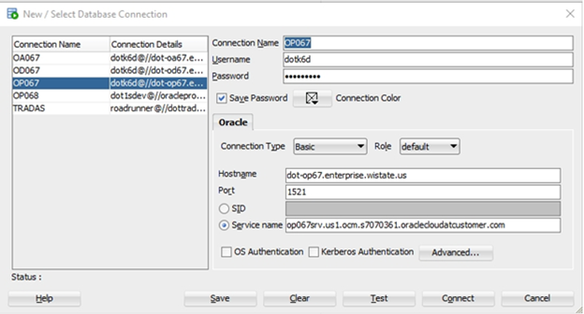

* 1. To view the data, expand the connection (after it is set up and connected)
     1. Go down and expand “Other Users”
     2. The Jackalope data is under “DOT1TDHO”
     3. Expand “Tables” or “Views” to select the table or view you want to look at
     4. There is some other count data under the DOT1TDMO user too

1. To determine which sites have truck percentages, use the following link to access ATR data in your region. (The sharepoint site also has some other information that you find useful)

[https://wigov.sharepoint.com/sites/dot-dtim/bshp/jackalope/SitePages/Home.aspx?RootFolder=%2Fsites%2Fdot%2Ddtim%2Fbshp%2Fjackalope%2Fdocuments%2FATRSiteListCapabilities&FolderCTID=0x01200026594E2DAC625C4E9FCE3EE23082C0E2&View=%7BB02D6995%2DD3D8%2D4DD3%2D8C46%2DB883BCA4EBA7%7D](mailto:erin.schoon@dot.wi.gov?RootFolder=/sites/dot-dtim/bshp/jackalope/documents/ATRSiteListCapabilities&FolderCTID=0x01200026594E2DAC625C4E9FCE3EE23082C0E2&View=%7bB02D6995-D3D8-4DD3-8C46-B883BCA4EBA7%7d)

1. Use the following SQL’s to export data to Excel for the WZTAT based on your site data availability. Below is description of each SQL and what is should be used for:
   1. Work Zone Engineer Data – Single Site: This will pull the volume only data from any site (whether it collects trucks or not).  For the volume only sites, this is the only report that can be run to get the data.
   2. 1 Hour Length Data by Direction: This will get truck and volume data. To get this data, use the WIM Sites and Loop & Piezo sites from the map on the sharepoint link.
   3. 1 Hour Class Data by Direction: This will get truck and volume data. To get this data, use the Loop Only Site and Wavetronix Sites from the map on the sharepoint link. One caveat with the “Loop Only Site” is that not all of those sites have 2 loops per lane, so they can only get volume data; the spreadsheet on the sharepoint link lets you know what sites have truck capabilities (they’re labeled length and class respectfully).
   4. Work Zone Engineer Data – Monthly Average Single Sites: This would represent the MV04 which takes the average of each hour for each day of the week (i.e. it averages all the Monday 9:00AM hours together for that number, all the Monday 10:00AM hours together for that number, etc.).  One thing to note about this report; it always starts with the first day of the month (i.e. 01-Feb-19 is February 1, 2019 which was a Sunday).  Therefore, every month does not start with the same day of the week so you will have to check back to see what day of the week the 1st is.  Also, most of the SQL’s have ‘2018’ for the year in the code, that will need to be changed if you are wanting to pull 2019 or any other year data.  All you have to do is change the 8 to a 9.

   

1. Once you identify the SQL you would like to use, you will need to copy the text.
   1. Within the SQL you will need to edit the Site ID and the starting date/ending date depending on what data you are looking for.
   2. Once the SQL Developer is open and you have followed the instructions in #3 above to create your connection, find your connection and select it. (My connection is called ‘Work Zone Tool’)
   3. Then copy and paste the text into SQL.

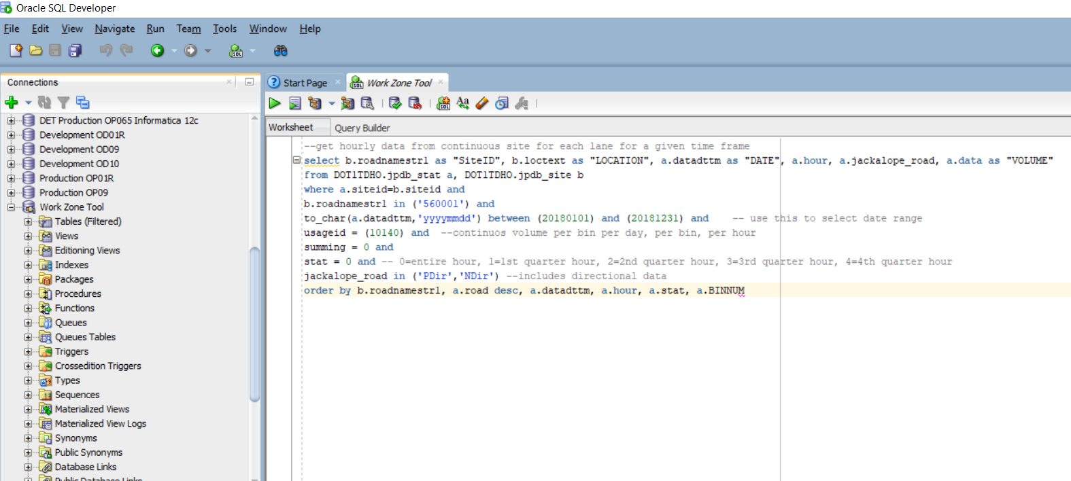

* 1. After the text appears in the worksheet, select the ‘play’ button, or ‘run statement’

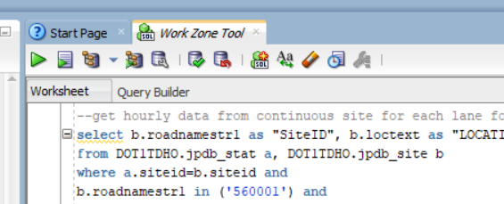

* 1. After the query runs, you will get a bunch of data in less than a minute. Right click on the data and select ‘export’ in the box that will appear.

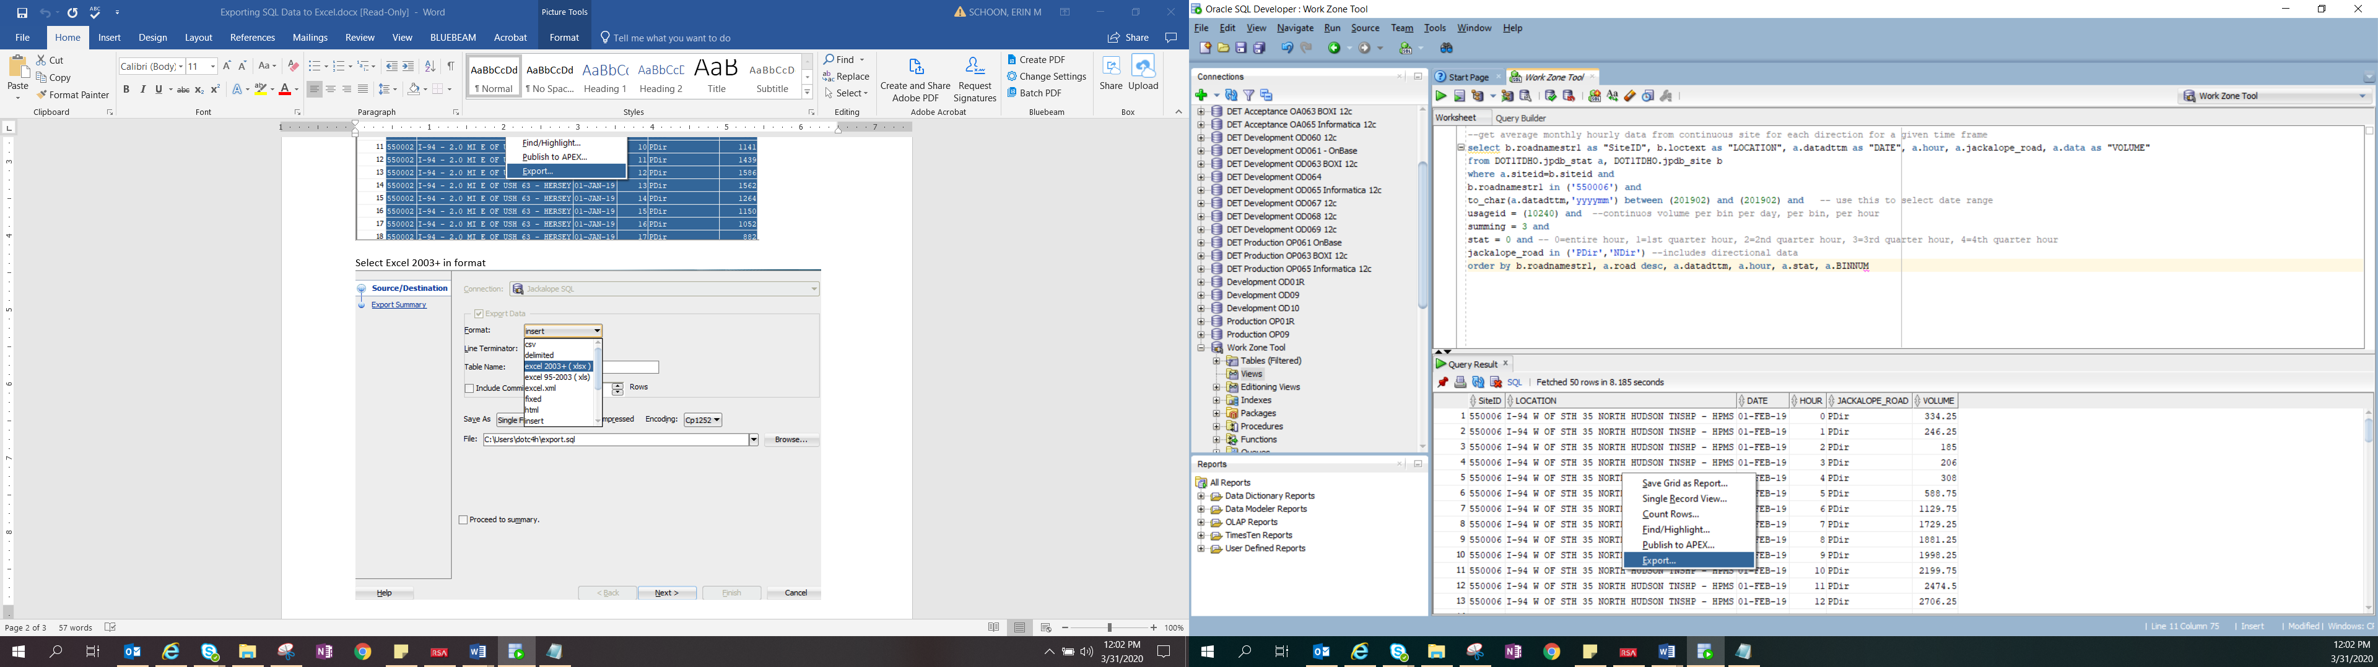

* 1. After clicking ‘export’, an export wizard will pop up. Select Excel 2003+ (xlsx).

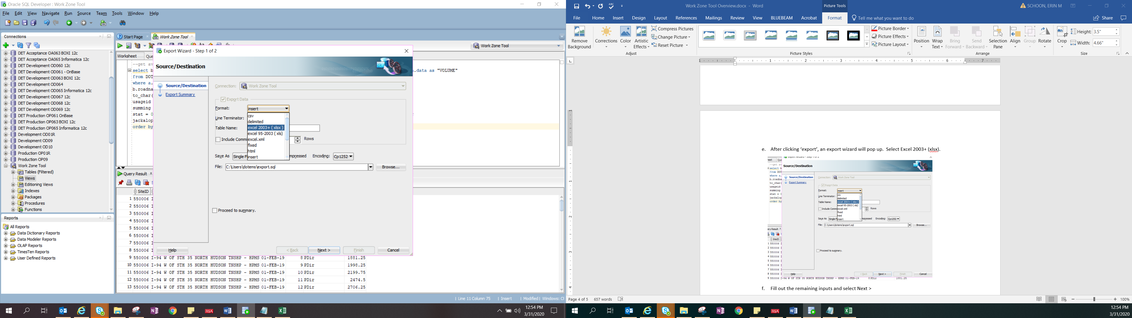

* 1. Fill out the remaining inputs and select Next >

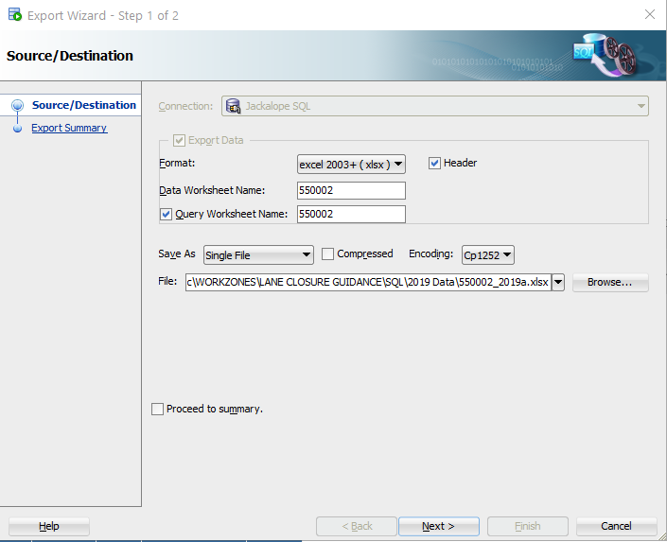

* 1. Select Finish

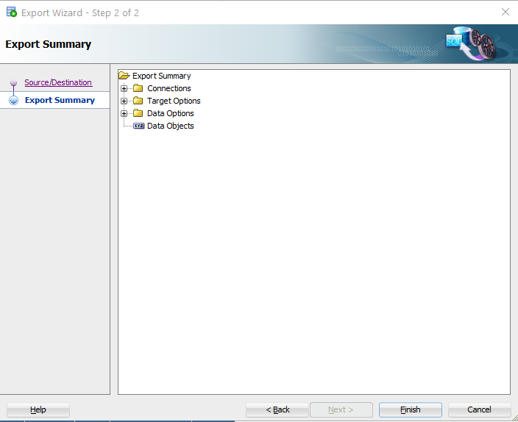

* 1. The file should be created in about 30 seconds or less.

1. Once the file is created it may be used in the work zone traffic analysis tool.

 

* 1. Open the Work Zone Traffic Analysis Tool (weekly/annual) and import your data.

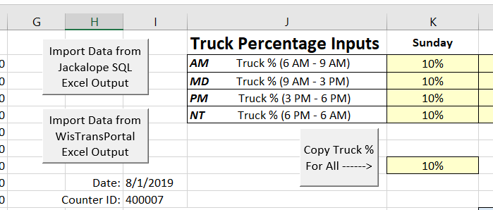

* 1. If your site has truck percentages the Truck Percentage Input table will not appear, if your site does not have truck percentages, you can enter truck percentages in based on peak hours, or as one truck percentage.



1. You should have all your volumes input into the spreadsheet and can work on filling out the rest of inputs in the tabs, determine your capacity and run the analysis for your proposed lane closure schedule. (See Work Traffic Analysis Tool ‘How to Guide’ for more detailed information on how to use the tool.)

If you have questions on the tool, please contact: Erin Schoon with the Bureau of Traffic Operations by either phone: 414-313-6841 or email: [erin.schoon@dot.wi.gov](mailto:traffic.counts@dot.wi.gov)